“DISCOVER THE 15 SECRET TOOLS THAT GURUS ARE USING TO BUILD THEIR ONLINE BUSINESS AND MAKE FULLTIME INCOME ”

Dear Friend,
Welcome and congratulations you have found the 15 secret tools that gurus are using to build their online business and make fulltime income!!! Here are the Software :

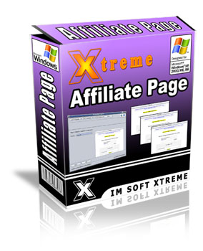 | XTREME AFFILIATE PAGE GENERATOR  (VALUE: $97)  - Creates your affiliate promotional pages just by following some step-by-step instructions  - Includes templates for the following promotional tools: Text links, Email Ads, Signature Ads, PopUp Ads, Image Ads, Articles & PPC Ads (leave all the hard work to us! You do not have to sweat over the various types of tools)  - Automatically embed the affiliate links of your affiliates into the promotional tools with just a click of the mouse! (literally spoon feed your affiliates!)  - Provides your affiliates with ready made promotional tools that they can instantly use for their promotional efforts (and let your affiliates do all the hard work in promoting your products with the tools you provide!)  - Make your affiliates WANT to promote your products because of the wide array of tools you provide  - Keep your affiliates happy and at the same time, build an ARMY of hungry affiliates who will increase the amount of sales and profits you make!  - and much more…
 | XTREME LINK ANALYZER  (VALUE: $67)  - Spy On Your Competitors  - Analyzes Link Popularity of Your Own Sites  - Show no. of Indexed Pages in Google and Yahoo  - Show Page Rank for 100’s of sites  - Show no. of Backlinks from 6 different sources: Google, Yahoo, Ask, AltaVista, AllTheWeb, Alexa.  - Show Alexa Rankings  - Export data in excel sheet for deeper analysis.  - and much more…
 | XTREME ARTICLE REWRITER  (VALUE: $97)  - Allows you to enter “seed articles” to gather information to build up a completely new and unique articles.  - Swap multiple paragraphs within multiple articles and create a completely customized version ready for article distribution.  - Input your own paragraphs and sentences that will be automatically added to articles at the top, middle and bottom of the content.  - Easily substitute thousands of synonyms to bypass google’s duplicate filter and still keep your main content.  - Select the number of paragraphs and sentences for each articles so that you have complete control on the output.  - Saves you a ton of time and effort and spare you from worrying over every single article you have to write ever!  - Creates your affiliate promotional pages just by following some step-by-step instructions  - and much more…
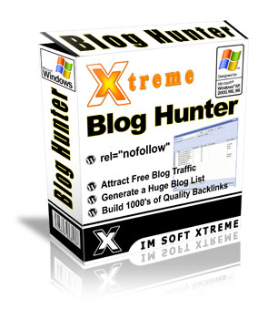 | XTREME BLOG HUNTER  (VALUE: $77)  Xtreme Blog Hunter offers the easiest and fastest way to generate a huge list of related blogs in any niche you choose which does not have the ‘nofollow’ attribute.  This help you to locate the best blogs you can leave comments on and build thousands of free backlinks to your website instantly!  You can even enter your own domain before the blog search and the software tell you if the blog already has your link and what anchor text used.  - Generate a huge blog list in any niche in seconds  - Build 1000’s of quality backlinks to your website instantly  - Locate blogs which does not have the “nofollow” attribute?  - Attract Free blog traffic to your website  - and much more…
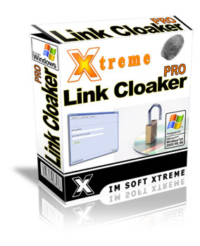 | XTREME LINK CLOAKER  (VALUE: $67)  Xtreme Link Cloaker Pro is created to help you protect your commissions and stop affiliate link hijacking and affiliate link bypassing.  Xtreme Link Cloaker Pro help you to avoid all pitfalls. And its very easy to use, doesn’t require any html skills, scripts to install or programming knowledge.  - Triple your sales with this AMAZING software!  - Simple and advanced link cloak functions  - Build trust between you and your buyer  - and much more…
 | XTREME CONTENT CHECKER  (VALUE: $67)  - Compares two articles side by side and reveal to you the percentage of duplicated content between the two articles  - Shows you exactly which are the parts that are duplicated using different color highlighting  - Saves you time and effort when rewriting articles due to the easy comparison  - Displays the keyword density of each article for the keyword you’ve chosen  - Helps to check on your freelance writers work and ensure all your content are not duplicated and will never be penalized by the search engines  - and much more…
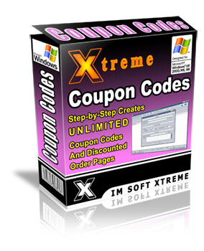 | XTREME COUPON CODE GENERATOR  (VALUE: $67)  - Creates unlimited coupon codes and discounted order pages just by following some step-by-step instructions (if you know how to click the mouse and follow instructions, you can use this software!)  - Set your promo codes to be self-expiring by a certain specific date (this creates a sense of urgency and scarcity for your prospects to take action immediately!)  - Ability to create “one-time-use” online coupon codes (so the coupon codes does not get abused!)  - Create special offers for your customers, JV partners, and affiliates (and boost your customers’ loyalty greatly and keep everyone happy!)  - View all your coupon statistics conveniently. You can track exactly how many times each of your coupon code has been used… (so you can create multiple codes and track which ones were the most effective!)  - and much more…
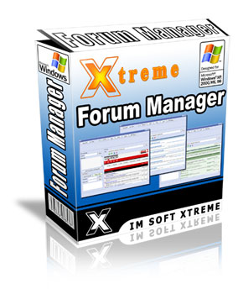 | XTREME FORUM MANAGER  (VALUE: $77)  Traffic from forums is highly effective because your signature can generate fast laser targeted niche traffic. The first thing to remember is that forums are communities, and communities thrive because of give and take relationships.  Effective posting in forums can produce quality traffic in hours or even sometimes minutes.  Xtreme Forum Manager allows you manage and organize your forum marketing efforts with just a few clicks of the mouse. Never has posting on a forum become so easy to do.  - Stores all your forums login details  - Easily Customize and Organize forum posts  - Store Preset Forum Postings  - Powerful Message Editor  - and much more…
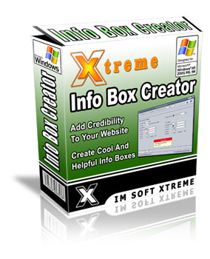 | XTREME INFO BOX CREATOR  (VALUE: $67)  - Allows you to create create little boxes of information i.e. help, hints, tips, tricks, FAQ by simply going through some easy steps (so you can churn out info boxes in just a fraction of the time others will take!)  - Let your site visitors easily grasp your site features and be able to navigate without facing any difficulties. (this will boost your site’s user-friendliness greatly!)  - Easily helps to add credibility to your websites with automatic insertion of the helpful hints you provide. (and show your visitors you care!)  - Make your site look professional with helpful info boxes for your visitors! (and enhance your visitors’ surfing experience and make them want to come back again and again!)  - Never have to worry about messing with complicated HTML codes or css files. As long as you know how to follow some simple instructions, you’ll be able to generate your own info boxes!  - Saves you a ton of time and effort and spare you from worrying over every piece of information you wish to provide on your sites!  - and much more…
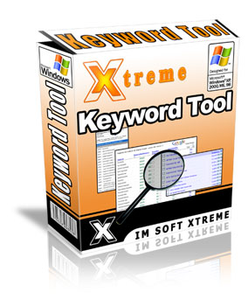 | XTREME KEYWORD RESEARCH TOOL  (VALUE: $77)  Keywords are one of the most critical keys to your online success. Keyword research combined with good unique content articles is a great way to drive free traffic to your website. And you need traffic… without it you don’t have an online business.  You can use Xtreme Keyword Tool to make a huge list of profitable niche keywords in no time to explode your Pay Per Click (PPC) campaigns, article research, bum marketing, product creation, website optimization and much more.  Xtreme Keyword Tool simple allows you to research top keywords in every niche market and also to check on the competition of the three major search engines instantly.  - Generate huge Keyword lists almost immediately  - Analyze the demand and supply of any niche market.  - Uncover hidden niche markets with a click of a button.  - Extract the no. of daily searches for any keyword in the search engines.  - Display number of competing pages for any keyword in Google, Yahoo & MSN.  - Save your keyword results in excel worksheet for deeper research  - and much more…
 | XTREME LINK DIRECTORY SUBMITTER  (VALUE: $97)  - It Contains over 200 directories that you can submit your sites to.  - The directory list is updated monthly (so all the dead links will be removed!)  - Automatically rotate multiple titles, descriptions and keywords to make sure your links seem natural and be able to rank for multiple keywords.  - Loads up to 10 browsers at the same time to speed up your submission process.  - Saves your previous work and records the sites that you have submitted to.  - Add, edit and delete anything in the directory list.  - Unlimited user and site profiles.  - Sort list according to Pagerank, Alexa rankings, alphabetical order, etc…  - and much more…
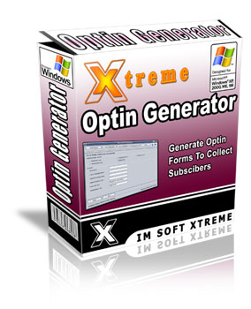 | XTREME OPTIN PAGE GENERATOR  (VALUE: $77)  - Allows your subscribers to receive their rewards INSTANTLY without having to go to another page  - Increases your optins magically by at least 200% and satisfy your prospects immediately  - Personalize your sales letter and address your prospects by name  - Boost your response rates by at least 30%  - Add images, videos, audios or anything else that can be possibly be placed on a website as a thank you message after they opt in  - Works with almost all of the main autoresponder services (such as Aweber, GetResponse and EmailAces)  - and much more…
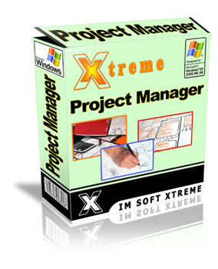 | XTREME PROJECT MANAGER  (VALUE: $67)  If you wish to be a successful marketer, save time and boost your productivity greatly, you need to master the art of effective time and project management skills. This software is the Lazy Marketers Secret Weapon to Success.  - Never miss a project deadline again  - Organize Your Time With This Amazing Software  - Powerful Calendar & Planning Tool  - and much more…
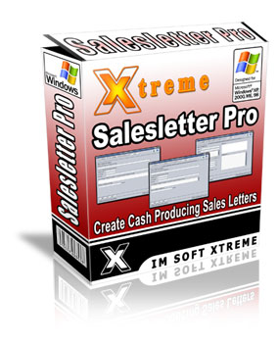 | XTREME SALESLETTER GENERATOR  (VALUE: $77)  - Allows you to create sales letters by simply filling in the blanks (so you can churn out sales copies in just a fraction of the time you would normally take!)  - Make your site look professional with a complete mini-site format as the software will allow you to enter your header, footer and product images with ease!  - Inputs the headline, sub-headline at strategic locations (so you can grab your prospects attention and make them read your offer!)  - Easily helps to add credibility to your sales page with automatic insertion of the testimonials you provide. (this will help boost sales tremendously!)  - 100% compatible with ANY payment processor (so you never have to worry about not being able to receive payment!)  - Extremely easy to integrate with Clickbank & Paypal – If you use Clickbank for your payment processor, you just have to insert your Clickbank ID and Product Number and the link will be created for your automatically. Likewise for Paypal!  - Saves you a ton of time and effort and spare you from worrying over every single sales letter you have to write ever!  - and much more…
 | XTREME SQUEEZE PAGE GENERATOR  (VALUE: $77)  Xtreme Squeeze Page Pro offers the fastest and easiest way to create top converting squeeze pages and can easily be customized according to your marketing needs with just a few clicks of the mouse  - Create unlimited amount of squeeze pages  - Choose between 3 different high-converting templates  - Easily Insert Meta Tags for SEO Purposes  - Enter Your Autoresponder Codes Directly  - Insert Audios/Videos and Images to Your Squeeze Pages  - Convert Your Squeeze Pages Project Directly into HTML  - and much more…..

RETAIL PRICE: $1,155
GET IT NOW: $37 ONLY!

Extremely Limited: This Offer Will End Anytime Soon. You Must BUY Them Now

To Your Viral Success,
Technocomp

